Vote for
US
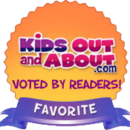
in KidsOutAndAbout.com’s annual survey of the
Top 20 Places to Take Kids in our area!
Go to https://www.surveymonkey.com/r/K2022SF
or just scan here:
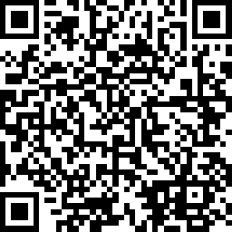

VOTING ENDS JUNE 19, 2022

